

**Rebalancing and the real exchange rate**

Speech given by

Ben Broadbent, External Member of the Monetary Policy Committee, Bank of England

At Thomson Reuters, London 26 September 2011

I would like to thank Alina Barnett and Adrian Chiu for research assistance and I am also grateful for helpful comments from other colleagues. The views expressed are my own and do not necessarily reflect those of the Bank of England or other members of the Monetary Policy Committee.

Some years ago, when in my last job, I conducted a small survey of investors. It was about central bank communication. Most of the questions involved how this should be done, but I also asked about the amount of it – is it possible for central bankers to talk too much? Given markets’ apparently insatiable appetite for information, I’d expected the answer to be a firm “no”. I was therefore surprised when almost 90% of respondents said “yes”. “Sometimes”, one of them wrote, “these people should just shut up”. Undeterred, here I am for my first speech.

I comfort myself that there is more to talk about these days. That survey was conducted in early 2006, after a long period of steady and undisturbed growth in the developed economies. We thought we’d answered most of the big questions about macroeconomic policy. After four years of extraordinary economic volatility, the Great Moderation (as it’s now known) seems a distant dream. And if we thought then that there was little for macroeconomists any longer to talk about, now it’s hard to know where to begin.

I have chosen today to talk about the exchange rate – specifically, the causes and consequences of sterling’s depreciation in 2007 and 2008. Any exchange rate is a relative price – it depends on *differences* between countries. This means I will put to one side much of what has affected the UK in recent years: the boom and bust in banks’ balance sheets and the huge swings in commodity prices (generally upwards) have all been *global* events, at least among the developed economies. You can see in Chart 1, which plots rolling correlations between output and domestic demand growth in the UK and their equivalents in the rest of the OECD, that the past few years have seen a very high degree of co-movement.

|  |  |  |  |  |  |  |  |
| --- | --- | --- | --- | --- | --- | --- | --- |
| **Chart 1: A synchronised cycle** | | | | | | | |
|  |  |  |  |  |  |  | 1 |
|  |  |  | Correlation in GDP |  |  |  |  |
|  |  |  | Correlation in domestic demand |  |  |  | 0.9 |
|  |  |  |  |  |  |  | 0.8 |
|  |  |  |  |  |  |  | 0.7 |
|  |  |  |  |  |  |  | 0.6 |
|  |  |  |  |  |  |  | 0.5 |
|  |  |  |  |  |  |  | 0.4 |
|  |  |  |  |  |  |  | 0.3 |
| 1980 | 1983 | 1986 | 1989 1992 1995 1998 2001 | 2004 | 2007 | 2010 |  |
| Note: Correlation is between growth rates in the UK and the OECD total.  Source: ONS and OECD | | | | | | | |

|  |  |
| --- | --- |
| **Chart 2: Recent depreciation large by historical standards** | |
|  | 120 |
| Sterling trade-weighted index |  |
| Jan-07 value | 110 |
|  | 100 |
|  | 90 |
|  | 80 |
|  | 70 |
|  | 60 |
| 1975 1978 1981 1984 1987 1990 1993 1996 1999 2002 2005 2008 2011 |  |
| Note: January 2007 = 100  Source: Bank of England | |

Whatever these common trends, however, differences between economies have also been big enough to warrant some significant moves in exchange rates, including the UK’s. Between 2007 and 2009, sterling’s effective exchange rate fell by 22%, the largest two-year decline since the devaluation of 1947 (Chart 2 plots daily data, which go back to 1975).

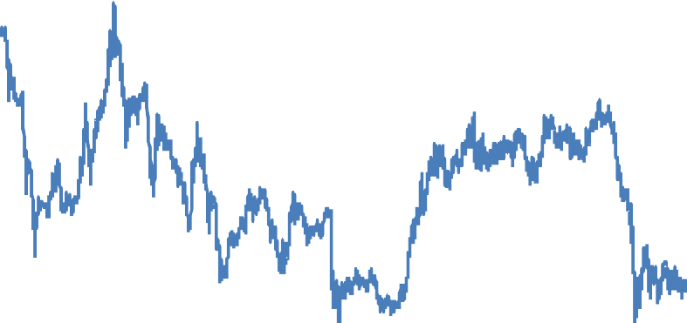

I’ll be making three points, and it’s worth summarising those up front:

First, the main cause of sterling’s decline isn’t monetary but real. Specifically, it reflects the need to rebalance UK supply – away from non-traded goods and services, and towards the production of tradables – in order to match an equivalent shift in the composition of demand. Over a number of years, and via a strong exchange rate, strong growth in that demand had “crowded out” the traded sector. As prospects weakened

* and I will make the point that the vulnerability of the public finances is particularly important in this respect
* the exchange rate had to fall in order to crowd it back in.

Second, the scale of the exchange-rate adjustment required for rebalancing depends centrally on how easy it is to move resources from one area of the economy to another. The point of it is to make the production of non-tradables less profitable, that of tradables more so: it is the economy’s way of pushing supply in the right direction. That incentive doesn’t need to be very strong if capital is mobile. But if – say – a dysfunctional financial system makes it harder to shift resources from low-return to high-return businesses, the required decline in the real exchange rate will be correspondingly larger. And during the transition, labour productivity, national income and the share of it paid out as wages will all be lower than they otherwise would

have been. Slow rebalancing, slow productivity growth and the scale of the depreciation may therefore be interrelated.

Third, though real (relative price) shocks needn’t have any impact on aggregate inflation, rigidly sticking to the inflation target through this period would have involved significant economic costs, costs that the MPC’s remit explicitly tells it to avoid. Given the scale of the adjustment going on underneath, stabilising the aggregate CPI would have required outright declines in prices of many non-tradables and, because their production is labour-intensive, declines in nominal wages as well. This in turn would probably have meant much higher unemployment. What the MPC has effectively done, therefore, is to employ the flexibility in its remit to accommodate part of this shock as a higher aggregate price level. And although these first-round effects have been significant and uncomfortable, contributing to a prolonged period of above-target inflation, it’s hard to detect any real sign of second-round effects on either wage growth or medium-term expectations of inflation. With the relative price adjustment now largely complete, that is very reassuring.

Let me go through these arguments in more detail. I will then draw some more general conclusions and say something about where we are today.

# The depreciation was not caused by monetary policy

In an open economy, monetary policy works partly via its impact on the exchange rate. All else equal, reductions in interest rates weaken the currency, increases strengthen it. It is tempting, therefore, to attribute every move in sterling to changes in monetary policy, particularly when you see something like Chart 3. This plots the Euro/Sterling exchange rate against the difference between their respective two-year interest rates. There looks to be a reasonable correlation, especially in 2008. Isn’t it obvious, therefore, that the MPC “caused” the depreciation1?

Not really. The problem with this interpretation is that sneaky phrase “all else equal”. This is a useful device

* to imagine what would happen in response to an arbitrary change in interest rates. But, in practice, policy generally changes for a reason: it reacts to things in order to offset their impact on medium-term inflation.

And the events that drive policy may themselves, quite independently, influence the exchange rate. Almost invariably, all else is not equal.

But if you can’t use interest rates themselves, how do you identify independent monetary policy events? I think one way to do it, at least in an inflation targeting framework, is to look at breakeven inflation rates in the

1 There is – or, at least, should be – a relationship between interest rates and the exchange rate independent of policy. The “uncovered interest parity” (UIP) condition says that, risk-adjusted, expected returns on two assets should be the same in any given currency (i.e. the expected risk-adjusted return on a “carry trade” is zero). But that doesn’t affect the argument here. First, the UIP condition pins down only the expected change in the exchange rate, not its level – it does nothing to rule out unexpected jumps unrelated to interest rates. Second, the remaining relationship says nothing about causality: it’s simply a consistency requirement. Third, as it happens, the relationship doesn’t perform that well in the data. In particular, carry trades seem to make money for long periods of time (albeit with a large negative skew in the distribution of returns, i.e. occasional blow-ups).

bond market. It is the job of policy to keep inflation on target over the medium term. So if short rates change but forward inflation rates do not, it’s reasonable to infer likely that policy is probably reacting “endogenously” to something else. Conversely, shifts in forward inflation rates can be interpreted as “exogenous” changes in the stance of policy, at least in the eyes of the gilts market.

|  |  |  |  |
| --- | --- | --- | --- |
| **Chart 3: Euro/Sterling exchange rate and interest rate differential** | | | |
| % |  |  |  |
| 3 |  |  | 1.7 |
|  |  |  | 1.6 |
| 2 |  |  | 1.5 |
|  |  |  | 1.4 |
| 1 |  |  |  |
|  |  |  | 1.3 |
| 0 |  |  | 1.2 |
|  | Difference in two-year swap rates (LHS) |  | 1.1 |
|  | Euro/Sterling (RHS) |  |  |
| -1 |  |  | 1 |
| 2000 | 2002 2004 2006 2008 | 2010 | 2012 |
| Source: Thompson Reuters | | | |

Chart 4 demonstrates what happens when you pass the exchange rate through this filter. It plots the rolling correlation, over four-year periods, between daily changes in the sterling trade-weighted index and in 3-year forward inflation rates (on the assumption that monetary policy takes that long to have its full effect on inflation).

Prior to 1992, when inflation targeting was introduced, the correlation is clearly negative. There seemed to be plenty of shocks (I’m interpreting them as “monetary policy”, broadly defined) that moved the currency and forward inflation in opposite directions. But it has generally been insignificantly different from zero since then – whatever events have affected the exchange rate, they have not been things that also affected forward inflation. This includes the four years since the onset of the financial crisis, in mid-2007.

Identifying pure changes in monetary policy is a longstanding and thorny problem in economics and I certainly don’t want to pretend that using forward inflation either solves the problem, or gets any closer to doing so that the many other solutions that have emerged over the years2. Its most obvious flaw is that bond

2 These include event studies (e.g. Romer and Romer, 1990) and structural time-series approaches that restrict either the time it takes for policy to work (Sims, 1980), its long-run effect on output (Blanchard and Quah, 1989) or, more loosely, the sign of those effects (e.g. Uhlig, 2005). Technically, using forward inflation is justified if there are rational expectations in financial markets, in which case bond prices embody any relevant public information at the time, including what can be captured by statistical techniques. But some may object to that assumption and you could in any case do better if, *ex post*, you can find information that signalled a change in policy but that was private at the time. This is what the event studies rely on.

markets can be wrong. RPI inflation in the first half of this year was 5.2%, 300bp higher than the market had projected three years earlier. Most forecasts of CPI inflation, including the MPC’s, turned out just as wrong. So isn’t it possible that monetary policy in 2008 and 2009 was, in fact, too loose, and that the fx market was simply the first to register the fact?

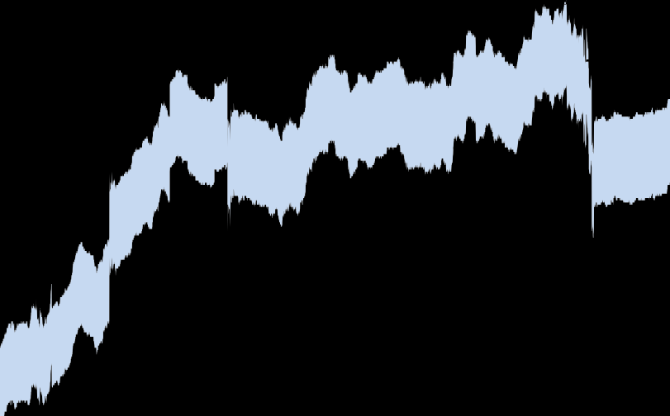

|  |  |  |  |  |  |  |  |  |  |
| --- | --- | --- | --- | --- | --- | --- | --- | --- | --- |
| **Chart 4: Changes in exchange rate and forward inflation rates no longer**  **correlated** | | | | | | | | | |
|  |  |  |  |  |  |  |  |  | 0.2 |
|  |  |  |  |  |  |  |  |  | 0.1 |
|  |  |  |  |  |  |  |  |  | -0.1 |
|  |  |  |  |  |  |  |  |  | -0.2 |
|  |  |  |  |  |  | 90% confidence band |  |  |  |
|  |  |  |  |  |  | Estimated correlation |  |  | -0.3 |
|  |  |  |  |  |  |  |  |  | -0.4 |
| 1989 | 1991 | 1993 | 1995 | 1997 | 1999 | 2001 2003 2005 2007 | 2009 | 2011 |  |
| Note: Correlation (daily data over 4-year rolling window) between nominal sterling EER and 3-year forward breakeven inflation.  Source: Bank of England and Datastream | | | | | | | | | |

I will discuss the recent behaviour of inflation later on. But let me just make a couple of points here. First, much of that surprise reflects subsequent, and unforeseen, factors such as the jump in commodity prices and the increase in the headline rate of VAT. They directly contributed around 2% points to inflation (whether CPI or RPI) during the first half of this year3.

Second, it requires a pretty perverse view of financial markets to imagine that fx traders should take one view of inflation, their colleagues on bond desks, sitting only a few feet away, another one entirely. In fact, it seems wholly implausible. What seems much more likely is that, if monetary policy were loosened significantly, independently of anything else, you would see sell-offs not just in the currency but in

(non-indexed) bonds as well. That’s not what happened in 2008.

3 It’s hard to be precise about this, not least because other things might have changed. But the impact must certainly have been considerable. Mechanically, the rise in the food and energy components and the increase in VAT each added around 1% to the CPI.

# The rebalancing of demand

Another way of looking at this is Chart 5. It plots the expected real exchange rate against the US dollar and the Euro (i.e. the nominal rate adjusted for cross-country differences in forward inflation4) five years forward. What it says – assuming that currency and inflation markets are, in fact, consistent with each other – is that sterling fell not because markets expected higher inflation in the UK, but because they judged that the relative value of UK output itself (the real exchange rate) would have to decline. Furthermore, it would have to do so at horizons well beyond those at which monetary policy is generally thought to have any impact on the real economy. Why was that?

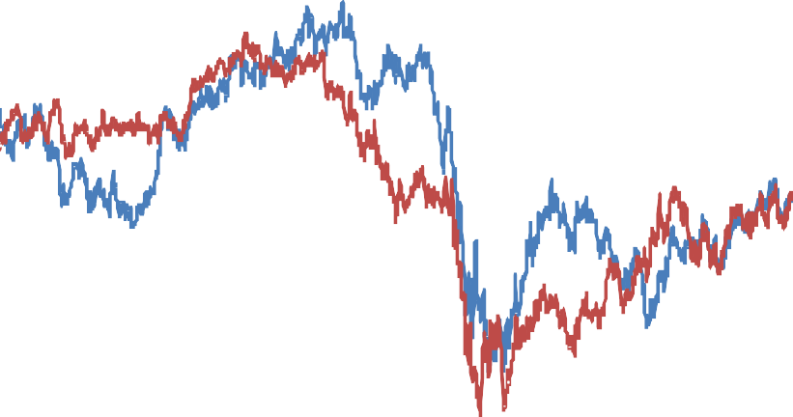

|  |  |  |  |  |  |
| --- | --- | --- | --- | --- | --- |
| **Chart 5: Decline not just in nominal spot exchange rate, but forward**  **real exchange rate too** | | | | | |
|  | USD/GBP forward real exchange rate EUR/GBP forward real exchange rate Jan-2007 value  2006 2007 2008 |  |  |  | 110 |
|  |  |  |  | 105 |
|  |  |  |  | 100 |
|  |  |  |  | 95 |
|  |  |  |  | 90 |
|  |  |  |  | 85 |
|  |  |  |  | 80 |
|  |  |  |  | 75 |
|  |  |  |  | 70 |
|  |  |  |  | 65 |
| 2005 | 2009 | 2010 | 2011 |  |
| Note: Forward spot rates adjusted for differences in breakeven inflation. UK series has been adjusted for estimated wedge between RPI and CPI inflation.  Source: Bank of England and Datastream | | | | | |

The real exchange rate tells you how much foreign output you get in return for one unit of UK output. It’s useful (and conventional) to split this relative price into two others: the price of the UK’s tradable output compared with that of our trading partners (the “terms of trade”) and the relative price of non-traded to traded output. Any sustainable move in the real exchange rate has to arise from a change in one or both these sources.

4 Not every country has an inflation market. Chart 4 plots the forward real sterling exchange rates against the US Dollar and the Euro.

These represent around two-thirds of the aggregate index. Given that the US dollar and the Euro have weakened against

emerging-market currencies, and that inflation has been higher in those countries, Chart 4 probably understates the decline in the real sterling EER, spot or forward.

In the UK, at least, the first is not an important source of variation. The terms of trade move around, but not by enough to have had much bearing on the real exchange rate (Chart 6).

|  |  |  |  |  |  |  |
| --- | --- | --- | --- | --- | --- | --- |
| **Chart 6: UK terms of trade do not explain movements in real sterling**  **EER** | | | | | | |
|  |  |  |  |  |  | 110 |
|  |  |  |  |  |  | 105 |
|  |  |  |  |  |  | 100 |
|  |  |  |  |  |  | 95 |
|  |  |  |  |  |  | 90 |
|  |  |  |  |  |  | 85 |
|  |  |  | Terms of trade |  |  |  |
|  |  |  |  |  |  | 80 |
|  |  |  | Real effective exchange rate |  |  |  |
|  |  |  |  |  |  | 75 |
|  |  |  |  |  |  | 70 |
| 1994 | 1996 | 1998 | 2000 2002 2004 2006 | 2008 | 2010 |  |
| Source: ONS and Bank for International Settlements | | | | | | |

It’s the second that matters more and, I believe, lies at the heart of what happened to sterling in 2008. Markets judged that the credit crunch would hit domestic demand – specifically the demand for stuff produced only domestically (non-tradables) – harder in the UK than in other countries. As a result the relative price of that output has had to fall. Strong demand for non-tradables had, over a period of years, and via a strong exchange rate, “crowded out” the economy’s traded sector; as the prospects for that demand suddenly weakened, the exchange rate fell in order to crowd it back in. Chart 7a gives you a stylised representation of such a shift. Why might it have occurred?

One reason for markets’ pessimism about domestic demand was the perception that the UK private sector is over-indebted. My own belief is that some of this was (and still is) overdone. But there are clearly areas of private-sector spending – most obviously residential investment – that had been growing strongly, relied predominantly on domestic suppliers and were financed largely by debt. When the supply of mortgage credit started to contract in late 2007, residential investment did so too, and by more than in the Eurozone. This must have contributed to sterling’s decline.

**Q**NT**/Q**T

**D** Impaired

**D** Normal

**S**

**P**NT**/P**T

**Chart 7a: Weaker demand for non-traded output depresses the exchange rate**

What I think was more significant, however, was the vulnerability of the public finances to the financial crisis. First, almost all government consumption (current spending on public services) goes on non-tradables.

Public services are themselves non-tradable (you can’t consume them except in the UK). And although the public sector buys some things that are bought and sold on international markets, the vast bulk of their expenditure, over 95% of it5, goes on things that are produced only domestically. This is why, in international data, there is a strong and well-established correlation between the real exchange rate and the share of government consumption in GDP. A recent IMF study, for example, found that a 1%-of-GDP increase in government consumption led (all else equal) to a 3% increase in a country’s real exchange rate6.

Second, the UK’s public finances were particularly exposed to the financial crisis. This is partly because Britain has very large banks. These generated a rising share of tax revenue in the years leading up to the crisis. When the crisis came, banks’ balance sheets – particularly their substantial overseas assets – also represented a significant potential liability for the UK taxpayer7.

5 Around half of government consumption is payments to (immobile) employees and, according to the UK Supply and Use Tables, the tradables weight of the rest – intermediate purchases by public services – is only 10%. That would put the overall share at around 5%. This overstates the true share, however, because the national accounts don’t include the opportunity cost of (or imputed rent from) land and buildings owned by the government. These are obviously non-tradable.

6 Ricci et al. (2008). See also Benetrix and Lane (2009) and Froot and Rogoff (1991).

7 The distinction doesn’t really matter in the current context, but it’s worth pointing out that the size of British banks’ balance sheets –

which were, indeed, significantly bigger than those in other countries (relative to GDP) – should not be confused with the size of the domestic financial sector. In 2007, financial services output accounted for 8% of UK GDP. This is higher than the 5% in France and Germany, but a lot lower than commentators often suppose. What really distinguished the British banks is the size of their overseas operations. These overseas assets were also responsible for most of banks’ losses.

These effects, especially the sensitivity of tax revenue8, are sizeable. In 2009-10 government receipts were over £100bn lower than the Treasury had forecast only two years earlier, in the March 2007 Budget. Not all of that, of course, is directly attributable to lower income from the financial sector9. But it’s nonetheless a very big number, only slightly less than the equivalent shortfall in national income (nominal GDP was £120bn lower than predicted), bigger than the decline in government receipts in the Eurozone (relative to GDP) and worth almost a third of current spending on public services. Even without markets’ concerns about the exposure of taxpayers to banks’ bad assets, and even relative to the UK’s trading partners, this was surely enough materially to contract the “envelope” of government consumption over the future and with it the demand for non-traded UK output.

# Rebalancing of supply

Demand is only half the story. As you can see from Chart 7b, the decline in the equilibrium real exchange rate depends not just on the shift in the demand curve but also on the slope of the supply curve. This, in turn, is a reflection of how easy it is to move resources from one sector to another – how easy it is to “crowd in” the tradables sector.

What does this mean in the real world? You can think of the depreciation, in this context, as an incentive device. It increases the return on capital in the traded sector and reduces it in the non-traded sector: it’s the economy’s way of ensuring that supply adapts to the shift in relative demand. If that process is straightforward – if factors are relatively mobile – the supply curve is flatter. You don’t need much of a nudge from the exchange rate. As the rebalancing takes place, the rates of return in the two sectors re-converge.

But if there are significant obstacles to factor mobility (if it’s hard to shut down businesses in one sector and grow them in another) the incentive has to be that much bigger. The slope of the supply curve, and (for any given shift in demand) the decline in the exchange rate, are both larger. And as long as the rebalancing is impeded in this way, in which case capital remains misallocated10, productivity, national income and the share of it paid out as wages11 (as opposed to capital income) will all be lower than they otherwise would be.

I think this captures some of what we’re going through now. We know that productivity growth tends to be slow in the aftermath of financial crises, and the UK economy today certainly fits that pattern: output per hour has risen at an annualised rate of only 0.7% since the end of the recession, far lower than the 3.6% average during other post-war recoveries. We also have compelling theoretical models that explain why a

8 The scale of the equity injections in 2008 and 2009 was very significant. But they are stocks, not flows. So the drop in tax revenue – over £100bn every year – is a much bigger contributor to the increase in public-sector debt. This is typical of the aftermath of financial crises (Reinhart and Rogoff, 2009).

9 There were also sharp declines in property-related taxes, though much of this is also directly attributable to the financial crisis and the ensuing contraction in credit supply.

10 It’s the mobility of capital, more than labour, that’s the important consideration here. On plausible parameters, and if there is CES

production in both sectors, the predicted slope of the supply curve in Chart 7 is predicted to be around 5 even when there is full labour mobility (but capital is fixed).

11 This last prediction requires that the elasticity of substitution between capital and labour is less than 1. Empirical estimates for the UK are between 0.5 and 0.7.

dysfunctional banking system, or other frictions in factor markets, can slow down the usual Schumpeterian process of “creative destruction”, i.e. the replacement of unprofitable activities by those that are newly profitable12. All I’m suggesting here is that, if this is true, then the most obvious example in the UK would be the failure to re-allocate resources from the non-traded to the tradable sector. There is a connection between slow productivity growth and slow rebalancing.

**Q**NT**/Q**T

**Decreasing factor mobility**

**D**

**S** Flex

**S** Inflex

**P**NT**/P**T

**Chart 7b: Impact is bigger when supply is less flexible**

This is mostly conjecture. Nor am I pretending that there aren’t other things – most obviously slow growth in the UK’s trading partners – that have held up rebalancing. But I will offer a couple of bits of supporting evidence for this supply-side story. Chart 8 plots estimates of gross margins in the consumer-facing sector (largely non-tradables) and the rest of the private economy (which has a much greater share of tradables). It shows a significant divergence between the two, suggesting a similar divergence in their rates of return.

Chart 9 shows that, despite this dispersion, and despite the depth of the recession, rates of start-ups13 and corporate bankruptcies have both been relatively low14.

12 Caballero and Hammour (1996 and 2001). See also Caballero et al. (2007).

13 In practice, growth comes more from the expansion of existing enterprises than the formation of new ones. So this start-up rate should be seen, in this context, merely as a (very rough) proxy for the wider failure to fund newly profitable economic activity.

14 The MPC argued last year, in the August 2010 *Inflation Report*, that a low corporate failure meant supply-side damage was small.

The suggestion here is that, at least if you take that series in conjunction with a low start-up rate, it may actually imply the opposite.

|  |  |  |  |  |  |  |
| --- | --- | --- | --- | --- | --- | --- |
| **Chart 8: Profit margins of the consumer-facing sector diverges from**  **the rest of the private economy** | | | | | | |
|  |  | PNFCs excluding oil  Non-consumer facing sector Consumer facing sector  1998 2002 |  |  |  | 115 |
|  |  |  |  |  | 110 |
|  |  |  |  |  | 105 |
|  |  |  |  |  | 100 |
|  |  |  |  |  | 95 |
|  |  |  |  |  | 90 |
|  |  |  |  |  | 85 |
|  |  |  |  |  | 80 |
| 1990 | 1994 | 2006 | 2010 | 2014 |  |
| Note: Gross profit margins proxied by value-added price relative to private-sector unit labour cost. Indexed to 100 at 1997-2007 average.  Source: ONS and Bank of England calculations | | | | | | |

Anyway, if this is true, it suggests that rebalancing and overall productivity growth will remain sluggish for as long as the banking system itself is in poor health. It also implies that, at least for given trends on the demand side, sterling’s real exchange rate will have to remain weak for some time to come.

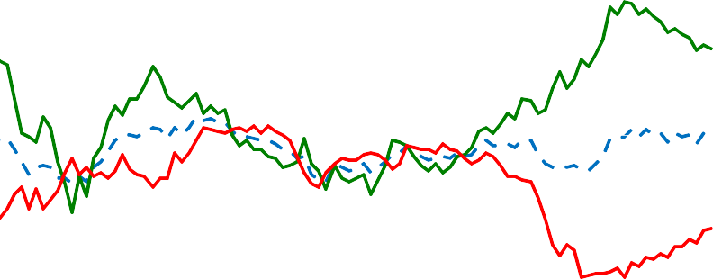

|  |  |  |  |  |  |  |  |  |  |
| --- | --- | --- | --- | --- | --- | --- | --- | --- | --- |
| **Chart 9: Rates of company formation, and of subsequent liquidation**  **much higher in last cycle** | | | | | | | | | |
|  |  |  |  |  |  |  |  | % |  |
|  |  |  |  |  |  |  |  |  | 18 |
|  |  |  |  |  |  |  |  |  | 16 |
|  |  |  |  |  |  |  |  |  | 14 |
|  |  |  |  |  |  |  |  |  | 12 |
|  |  |  |  |  |  |  |  |  | 10 |
|  |  | Birth rate |  |  |  |  |  |  |  |
|  |  | Death rate |  |  |  |  |  |  | 8 |
|  |  |  |  |  |  |  |  |  | 6 |
| 1980 | 1984 | 1988 | 1992 | 1996 | 2000 | 2004 | 2008 |  |  |
| Source: ONS and Department for Business Innovation & Skills | | | | | | | | | |

# The implications for inflation

I’ve argued so far that, despite the coincidence with falling interest rates, sterling’s dramatic depreciation in 2008 was driven not by monetary but by real forces. At a stroke, the financial crisis exposed the UK to the troubled assets of its large banks. More significantly, it reduced national income – above all government revenue – by more than in other countries. This meant that demand for UK (non-traded) output, and therefore its relative price, were bound to decline, that much more so in the presence of a sclerotic banking system that is finding it hard to reallocate capital.

But why should this have anything to do with inflation? All this would occur even in a world with full market clearing and no spare resources (Charts 7). In any event, this is a shock to *relative* prices. There’s no necessary reason why there should be any implications for *aggregate* inflation. The UK has a floating exchange rate and monetary independence. It can, over any reasonable period of time, choose its own inflation rate. Relative prices change all the time, even when overall CPI inflation is stable – so why was this one inflationary?

The difference in this case, I believe, is one of scale. To have stuck rigidly to the inflation target, while a relative price adjustment this large was taking place, would have required a sizeable drop in the price of

non-traded output not just in relative terms but in absolute terms as well15. Because the non-traded sector is labour-intensive that, in turn, would probably have meant a decline in nominal wages and, in order to produce it, a significant increase in unemployment. This is especially true if (as the evidence suggests16) the Phillips curve flattens out at low levels of wage inflation.

In other words, the MPC could have kept inflation closer to target through this period (the impact on inflation was not unavoidable). It’s just that doing so would have meant an unacceptably high cost in foregone output and employment17. Instead, and in order to prevent nominal wages from falling, a part of the relative price adjustment was allowed to feed through to aggregate prices.

This hasn’t been without risk. High spot inflation increases the chances of “second-round” effects on inflation expectations. Price-setters in the private economy might begin to assume that this new, higher rate of inflation is the new norm. That’s why, at various points over the past year or so, some MPC members have voted for a small rise in interest rates.

15 Suppose that the share of traded output in the CPI is t and that rebalancing means its price, relative to that of non-traded output, has to rise by an amount Δ. In that case, the change in the aggregate CPI is dp = dpn + tΔ where pn is the price of non-tradables. So if you want to make sure that aggregate prices don’t change (dp =0) then non-traded prices have to fall by tΔ. If (as the fx market initially implied) the required relative price shift is 15%, and if a third of the CPI is tradables, that would mean a 5% drop in the rest of the index. 16 See Akerlof et al. (1996) and Meier (2010)

17 David Miles (2011) made exactly this point in a speech in February this year: “Monetary policy could be set so that...inflation moves back to target significantly more rapidly than in the *Inflation Report*. For that to happen, it would probably need a significantly greater

degree of slack...and higher unemployment. But I am very sceptical about whether it is desirable”.

But there are three important things to bear in mind. First, it is not the job of the MPC – or, for that matter, any inflation-targeting monetary authority18 – to keep inflation on target at all times, come what may. There is clearly room for interpretation as to what it means in practice, but the MPC’s remit states explicitly that it would be “neither possible nor desirable” to keep CPI inflation at 2% at all times and that the aim is instead to “bring inflation back to target within a reasonable period of time without creating undue instability in the economy”.

Second, inflation expectations have actually remained pretty well anchored over the past three years. Longer-term survey measures are close to their historic averages. Though there are plenty of other reasons why this is true, private-sector pay settlements are below average. The MPC will have to remain vigilant for

such effects. But I see little evidence that, so far at least, high spot inflation has materially dented confidence in the inflation target over the medium term. With the relative price change now largely complete, that is very reassuring.

Third, and most importantly for policy today, the international environment is clearly disinflationary. The ‘common factors’ I referred to earlier – slow growth in the United States, the sovereign debt crisis in the Eurozone and its knock-on effects on the cost of finance for UK and European banks – all threaten a further tightening in retail credit and a further slowing in domestic activity. Indeed, these effects are already visible and, over the medium term, look set to dominate any remaining “pass-through” from sterling’s depreciation to domestic inflation.

There are clearly other policies – above all in the Eurozone – that would forestall some of these things, and do so more effectively than UK monetary policy alone could ever hope to. But that doesn’t mean either that UK monetary policy is powerless or that it doesn’t have its own role to play.

# Summary and some conclusions

Many economic commentators, particularly in recent years, have tended to see exchange rates as a battleground – countries are frequently said to be involved in “currency wars”. In 2008 and 2009, the MPC was often labelled as a combatant, accused of deliberately deflating the value of the UK currency. Never mind that there might have other reasons for sterling’s depreciation. Inflation subsequently rose, by more than in other countries, and if something walks and quacks like a duck, then surely it’s a duck.

It’s clear that such international tensions exist. But at least as far as sterling’s depreciation is concerned, the military analogies are overdone. For one thing, the currency weakened but the bond market did not. So if one leg was duck-like, the other certainly wasn’t. Second (forgive the over-extension of the duck metaphor)

18 In his overview of inflation targeting in the latest *Handbook of Monetary Economics*, Lars Svensson (2010) says that “In practice, inflation targeting is never ‘strict’ but always ‘flexible’, in the sense that all inflation-targeting central banks aim not only at stabilising inflation around the target but also put some weight on stabilising the real economy.”

much of the subsequent quacking came from other sources, notably commodities and indirect taxes. Third, we have good reason – the need to rebalance supply, following an inescapable, crisis-induced rebalancing of demand – to believe what the financial markets told us at the time, namely that sterling’s depreciation was primarily the result of a decline in the equilibrium real exchange rate. A dysfunctional banking system, or any other impediment to the reallocation of supply, can only have amplified that decline.

That doesn’t tell the whole story. Some of the inflation – and also the depreciation – probably have been the result of a *de facto* accommodation on the part of monetary policy. That’s because sticking rigidly to the inflation target would have meant a much larger rise in unemployment, and the remit of the UK MPC, like that of other inflation targeters, rightly avoids that prescription. In the meantime, medium-term inflation expectations have remained broadly stable.

I think there are some longer-term lessons to be drawn from this. One is that the credibility of the UK’s inflation-targeting regime looks reasonably robust. That’s clearly not something that can, or should, be taken for granted. Credibility is earned, over time, by keeping inflation close to its target. But it is striking how stable both pay growth and medium-term inflation expectations have been in the face of these relatively large swings in spot inflation.

Second, however, even credible monetary policy has its limits. The long rise in commodity prices, the financial crisis and the sluggish rebalancing of supply have all acted to reduce real household incomes. It matters to some degree whether this occurs via higher inflation or lower nominal wages, because the latter route would probably have involved higher unemployment, if only for a time. Credibility means monetary policy can, within limits, choose the former course. But the hit to real incomes would have occurred either way.

Third, controlling inflation is harder when the real economy is more volatile. In that sense, the last few years have borne out the pessimistic promise of the Governor’s speech eight years ago (King (2003)), in which he warned us not to count forever on the benign environment of the previous, “NICE” decade (NICE standing for “Non-Inflationary Consistently Expansionary”). The early years of globalisation brought steady rises in the terms of trade, steady declines in long-term real interest rates and, thanks in part to the accompanying growth in banks’ balance sheets, buoyant government revenue. All that made it easier to keep inflation low, and most of it has since been reversed. One can hope, at least, that the next few years will be not be as difficult as the last few have been. Equally, I rather doubt my time on the MPC will be as “NICE” as the Great Moderation.

Finally, having acknowledged at the start that monetary policy makers are often thought to talk too much, I fear I have done precisely that.

So thank you for your patience.

**References**

**Akerlof, G.A., Dickens, W.T and Perry, G.L. , (1996)** “The Macroeconomics of Low Inflation”, Brookings Papers on Economic Activity, pp. 1–59.

**Benetrix, A. and Lane, P. (2009)**, “Fiscal Shocks and the Real Exchange Rate”, The Institute for International Integration Studies Discussion Paper Series, No. 286.

**Blanchard, O. and Quah, D. (1989)**, “The Dynamic Effect of Aggregate Demand and Supply Disturbances”, American Economics Review, Vol. 79, No. 4.

**Caballero, R. J. and Hammour, M. L. (1996)** "On the Timing and Efficiency of Creative Destruction”, Quarterly Journal of Economics 111.

**Caballero, R. J. and Hammour, M. L. (2001) “**Institutions, Restructuring, and Macroeconomic Performance", in Advances in Macroeconomic Theory, ed. J.Dreze.

**Caballero, R. J., Hoshi T and Kashyap A. (2007) “**Zombie Lending and Depressed Restructuring in Japan”, American Economic Review 98.

**Froot, K. and Rogoff, K. (1991)** “The EMS, the EMU, and the Transition to a Common Currency”. NBER Macroeconomics Annual 1991 Volume 6

**King (2003),** Speech given to East Midlands Development Agency, available at: <http://www.bankofengland.co.uk/publications/speeches/2003/speech204.pdf>

**Meier, A. (2010),** “Still Minding the Gap- Inflation Dynamics during Episodes of Persistent Large Output Gaps”, IMF Working Paper 10/189

**Miles, D. (2011)**, “Monetary Policy in Extraordinary Times”. Speech to the Centre for Economic Policy Research and London Business School, London, available at: <http://www.bankofengland.co.uk/publications/speeches/2011/speech475.pdf>

**Romer, C. and Romer, D. (1990)**, “Does Monetary Policy Matter? A New Test in the Spirit of Friedman and Schwartz”, NBER Working paper, No. 2966, National Bureau of Economic Research.

**Ricci, L., Milesi-Ferretti, G. M. and Lee, L. (2008)** “Real Exchange Rates and Fundamentals: A Cross-Country Perspective.” IMF Working Paper No. 08/13.

**Reinhart, C and Rogoff, K. (2009)** “The Aftermath of the Financial Crisis”, NBER Working Papers 14656, National Bureau of Economic Research.

**Sims, C. (1980)**, "Macroeconomics and Reality", Econometrica, 48.

**Svensson, L. (2010)** “Inflation Targeting”, in Friedman, Benjamin M., and Michael Woodford, eds.,

*Handbook of Monetary Economics, Volume b*, chapter 22, Elsevier

**Uhlig, H. (2005)**, ‘What are the effects of monetary policy on output? Results from an agnostic identification procedure’, Journal of Monetary Economics, Vol. 52, pages 381.419.